AP Chemistry

Unit 3
Light, Electronic Structure, and Periodic Trends

Set 8. The Bohr Model & Light

Skill 8.01: Understand the relationship between wavelength, frequency, energy, and light color
Skill 8.02: Describe Bohr’s theory of the hydrogen atom and how it accounts for line spectra
Skill 8.03: Describe the effect of nuclear charge on the energy an atom emits

Skill 8.01: Understand the relationship between wavelength, frequency, and light color

From fireworks to stars, the color of light is useful in finding out what’s in matter. The emission of light by hydrogen and other atoms has played a key role in understanding the electronic structure of atoms. Trace materials, such as evidence from a crime scene, lead in paint or mercury in drinking water can be identified by heating or burning the materials and examining the color(s) of light given off in the form of bright-line spectra.
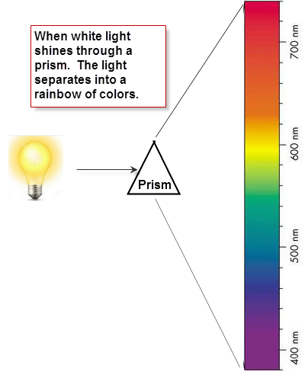
Skill 8.01. Problem 1
Refer to the figure shown to the right. Identify the range of wavelengths associated with each color. The “Reds” have already been filled in.
Color Range | Wavelengths
Reds | 680–740
Oranges

Yellows

Greens

Blues

Violets

Light consists of electromagnetic waves. Electromagnetic waves are characterized by their wavelength and frequency:

- The wavelength, λ (lambda) is the distance between identical points on successive waves.
- The frequency, ν (nu), is the number of waves that pass through a particular point in one second.

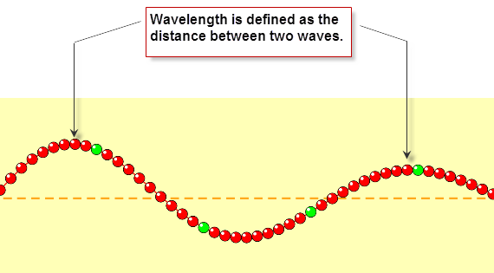

Skill 8.01. Problem 2.
Navigate to the wave on a string simulator.

http://phet.colorado.edu/sims/html/wave-on-a-string/latest/wave-on-a-string_en.html

Once there, select the “No end” option and the “Oscillate” option
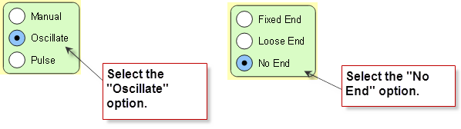

- Locate the frequency slider. Move it back and forth and observe how the wavelength changes.

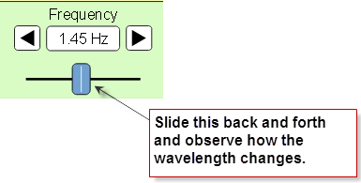
- When you increase the frequency, what happens to the wavelength? Does it increase or decrease?

- When you decrease the frequency, what happens to the wavelength? Does it increase or decrease?

- What is the relationship between frequency and wavelength? Is it inverse or direct?

- Refer to the colors below. Sort the colors from low to high with respect to frequency.

Color Range | Order of frequency (1 = lowest)
Reds

Oranges

Yellows

Greens

Blues

Violets

- Now return to the simulator. Select the “Manual” option.
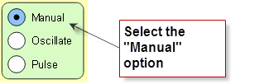
Move the wrench up and down as fast as you can and observe the wavelength. Now move the wrench up and down slowly and observe the wavelength.

- When you moved the wrench up and down quickly (high energy), what happened to the wavelength? Did it increase or decrease?

  - When you moved the wrench up and down slowly (low energy), what happened to the wavelength? Did it increase or decrease?

  - What is the relationship between energy and wavelength? Is it inverse or direct?

- Refer to the colors below. Sort the colors from low to high with respect to energy.

Color Range | Order of energy (1 = lowest)
Reds

Oranges

Yellows

Greens

Blues

Violets

- Write a sentence that describes the relationship between wavelength and energy of light.



Skill 8.02: Describe Bohr’s theory of the hydrogen atom and how it accounts for line spectra

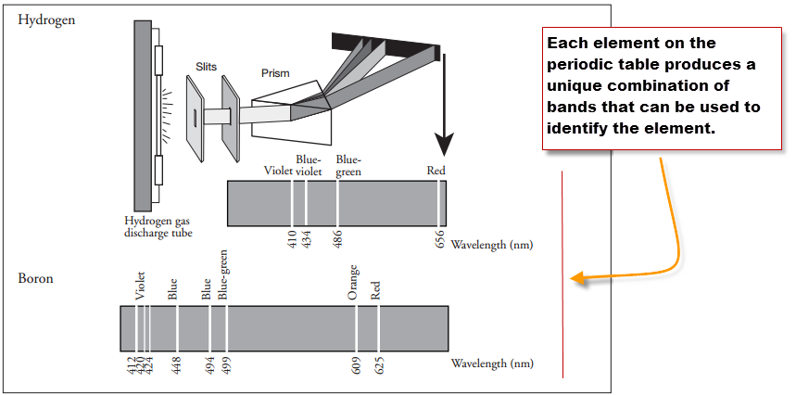
Experiments showed that the light emitted from individual elements did not produce the rainbow observed by the separation of white light.
Instead, when the light from individual elements were separated with a prism, only light of specific wavelengths appeared.

Notice in the picture to the left, when the light from hydrogen is separated with a prism only 4 light bands appear. When the light from boron is separated with a prism, 8 bands of light appear.

Skill 8.02. Problem 1
Refer to the diagram below to complete the following
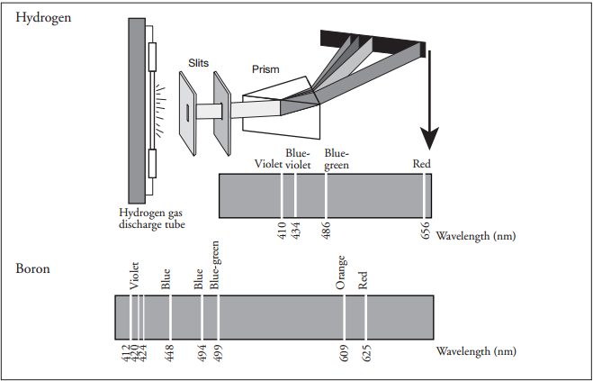
  - Use colored pencils to color the hydrogen and boron spectral lines within their respective spectra.

  - List the spectral lines for hydrogen gas by color and corresponding wavelength. Sort the colors from low to high with respect to energy.

Color | Wavelength | Order of energy (1 = lowest)

To account for the line spectra produced by elements, Bohr proposed that electrons could only be located in certain orbits. Since each orbit has a particular energy associated with it, the energies associated with an electron is fixed (or quantized). Bohr suggested that when the electron absorbs a photon of energy it jumps to a higher energy level. When the electron drops to a lower energy level, it releases a photon of energy in the form of light as shown in the figure below.

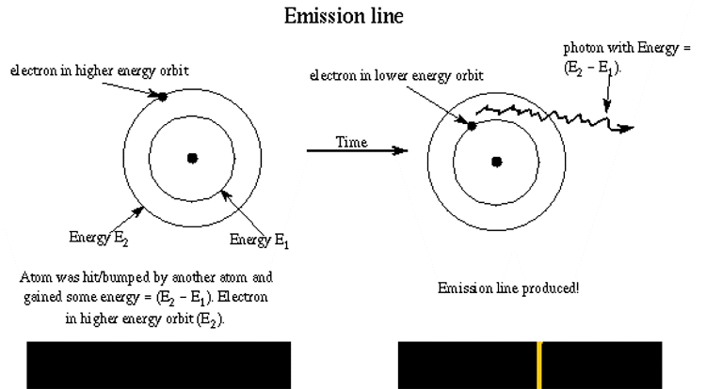
Skill 8.02. Problem 2
Navigate to the following link,

https://sites.google.com/a/boiseschools.org/bohratom/

Navigate through the tutorial then complete the following questions.
- Is energy absorbed or released for the electron transition shown in the diagram to the right? How do you know? | 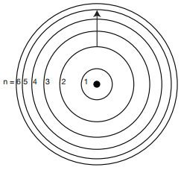
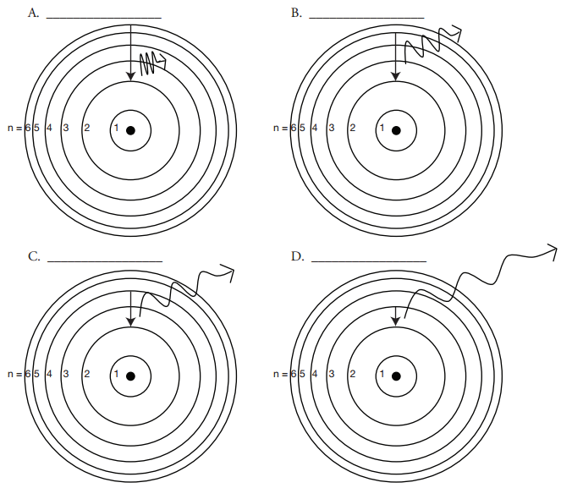
- The diagram above shows the allowed transitions in the hydrogen atom.

- For the transitions shown, is light being absorbed or emitted? How do you know?

- Complete the following table. Refer to the spectrum you colored in “Skill 8.02 Problem 1” to identify the color of emitted for each transition.
Picture | Transition | Color of light | Order of energy (1 = lowest)
A | n= ___ to n= ____
B | n= ___ to n= ____
C | n= ___ to n= ____
D | n= ___ to n= ____

- What is the relationship between the transition and energy of light emitted? In other words as the length of the transition increases, does the energy that is emitted increase or decrease?

Skill 8.03: Describe the effect of nuclear charge on the energy an atom emits

Up until now we have only been concerned with transitions that produce energies that are visible to us. But there are other types of energies that are produced that we cannot see. The diagram shows the various energies that can be produced as electrons undergo transitions in an atom. Notice that we can only see a small sliver of this energy.

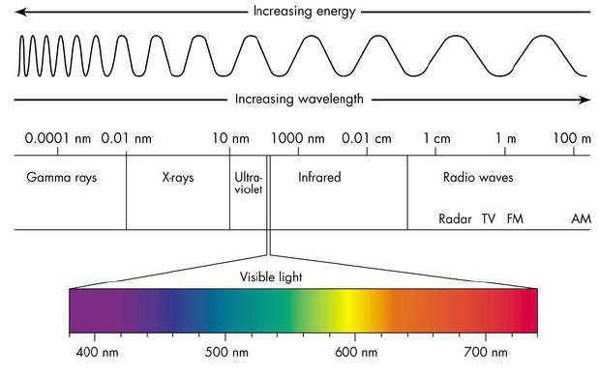
Skill 8.03. Problem 1
Refer to the diagram above then rank the following from low to high with respect to energy.
Energy | Order of energy (1 = lowest)
Gamma rays
X-rays
Radio waves
Visible light
Ultra-violet
Infrared

Skill 8.03. Problem 2
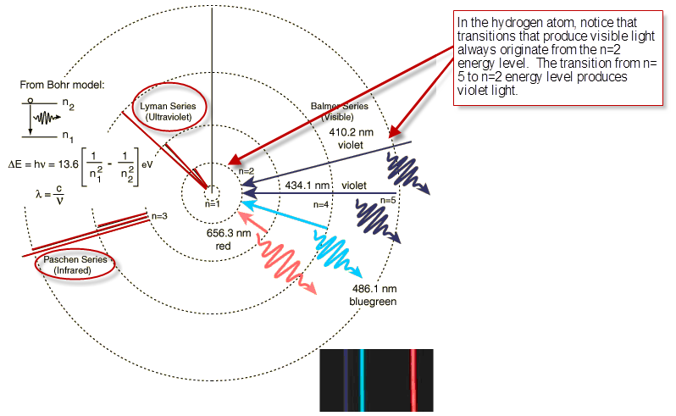
- The diagram above shows transitions that result in Infrared energy, Ultra Violet energy, and Visible energy. Notice that visible always originates from the n=2 energy level. From which energy level does.

- Infrared energy originate?

- Ultraviolet energy originate?

- Complete the follow table. Rank each energy according to the energy level from which the electron originated. Rank each from high to low with respect to energy.

Energy | Distance from the nucleus (1 = closest) | Order of energy (1 = lowest)
Ultra violet
Infrared
Visible

- What is the relationship between the distance from which an electron originates and its energy. In other words, do electrons that originate closer to nucleus have higher or lower energy than electrons that originate farther from the nucleus? Write a sentence that describes this relationship.

As you previously learned, atoms have protons and electrons. And because protons have a positive charge and electrons have a negative charge, it follows that they are attracted to one another. Binding energy, is the energy required to remove an electron from an atom.

Skill 8.03. Problem 2
The graph below shows the relationship between the mass number of an atom and the binding energy.
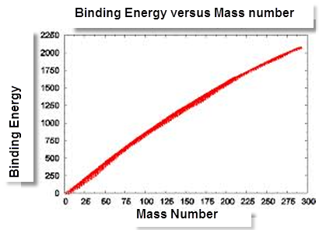
  - According to the graph, is the relationship between binding energy inverse or direct? In other words as the mass number increases does the binding energy increase or decrease?

  - Is the relationship between the number of protons in an atom and the binding energy inverse or direct?

  - Consider the following atoms, rank the atoms from low to high with respect to binding energy: H, He⁺, Ne²⁺

  - Now consider the following transition.

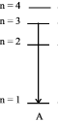
Complete the table to show how the energy released compares between different atoms.
Atom | Order of energy (1 = lowest)
He⁺
Li²⁺
H
Be³⁺

Set 8.0 Practice Problems

  - What is the wavelength (in meters) of an electromagnetic wave whose frequency is 3.64 x 10⁷ Hz?

  - (a) What is the frequency of light having a wavelength of 456 nm? (b) What is the wavelength (in nanometers) of radiation having a frequency of 2.45 x 10⁹ Hz?

  - Calculate the energy (in joules) of (a) a photon with a wavelength of 5.00 x 10⁴ nm and (b) a photon with a wavelength of 5.00 x 10⁻² nm.

  - The energy of a photon is 5.87 x 10⁻²⁰ J. What is the wavelength (in nanometers)?

  - What is the wavelength (in nanometers) of a photon emitted during a transition from n_{i} = 6 to n_{f} = 4 state in the H atom?

  - Calculate the frequency (Hz) and wavelength (nm) of the emitted phton when an electron drops from the n=4 to the n=2 level in a hydrogen atom.

  - An electron in the hydrogen atom makes a transition from an energy state of principal quantum number n_{i} to n = 2 state. If the photon emitted has a wavelength of 434 nm, what is the value of n_{i}?

  - Answer the following questions regarding light and its interactions with molecules, atoms, and ions.

- The longest wavelength of light with enough energy to break the Cl-Cl bond in Cl₂(g) is 495 nm.

(i) Calculate the frequency, in s⁻¹, of the light
(ii) Calculate the energy, in J, of a photon of the light.
(iii) Calculate the minimum energy, in kJ/mol, of the Cl-Cl bond

- A certain line in the spectrum of atomic hydrogen is associated with the electronic transition in the H atom from the sixth energy level (n=6) to the second energy level (n=2).

(i) Indicate whether the H atom emits energy of whether it absorbs energy during the transition. Justify your answer.
(ii) Calculate the wavelength, in nm, of the radiation associated with the spectral line.
(iii) Account for the observation that the amount of energy associated with the same electronic transition (n=6 to n=2) in the He⁺ ion is greater than that associated with the corresponding transition in the H atom.

Set 9. Quantum Model of the Atom

Skill 9.01: Construct Bohr models for atoms, define the Principle Quantum Number (n), and identify the maximum number of electrons that each principle energy level can hold
Skill 9.02: Define the Angular Momentum quantum number and identify the possible values
Skill 9.03: Define the Magnetic quantum number and identify the possible values
Skill 9.04: State Hund’s rule, state the Pauli exclusion principle, define the Spin quantum number (m_{s}) and identify its possible values and arrangements
Skill 9.05: Identify whether an atom is diamagnetic or paramagnetic

Skill 9.01: Construct Bohr models for atoms, define the Principle Quantum Number (n), and identify the maximum number of electrons that each principle energy level can hold

Skill 9.01 Concepts

To account for the line spectra produced by elements, Bohr proposed that electrons could only be located in certain orbits. Since each orbit has a particular energy associated with it, the energies associated with an electron is fixed (or quantized). Bohr assigned each of his quantized electron orbits, called shells, a principal quantum number (n), starting with n=1 for the shell closet to the nucleus, n=2 for the next shell out from the nucleus, and so on (figure 1).

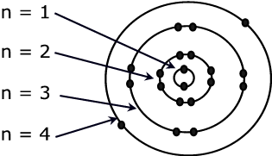 | The letter ‘n” is used to denote the energy level the electron is located. As the electron’s distance from the nucleus increases so too does its potential energy.
Figure 1. Bohr model.

All the electrons in an atom want to occupy the n=1 shell, because it is the shell closest to the nucleus. But electrons repel each other, so there is a maximum number of electrons that each shell can hold. The further out from the nucleus, the larger the shell, and the more electrons that can be accommodated.

The maximum number of electrons that each shell can hold is equal to 2n², where n is the principle quantum number of the shell.

Skill 9.01 Example 1
Draw Bohr models for the following atoms:

- H, Li, Na
- Be, Mg, Ca
- C, Si, Ge
- Ne, Ar, Kr

What does each group of atoms have in common?
Group I | H | Li | Na
Group II | Be | Mg
Group IV | C | Si
Group VIII | Ne | Ar

Skill 9.02: Define the Angular Momentum quantum number and identify the possible values

Skill 9.02 Concepts

Later experiments with light showed that the arrangement of electrons in the atom was much more complex than what the Bohr model was able to explain.

Recall that Bohr suggested that when the electron absorbs a photon of energy it jumps to a higher energy level. When the electron drops to a lower energy level, it releases a photon of energy in the form of light BUT, later experiments showed that the bands of light Bohr observed were actually made up of multiple bands (figure 2).

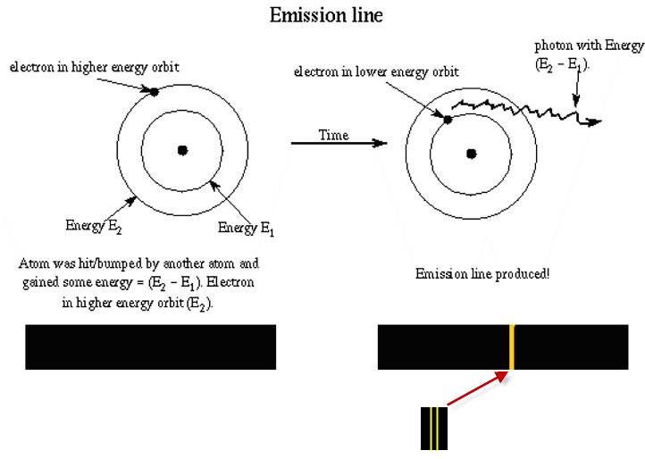
Figure 2. Notice that the broad band is actually made up of smaller bands.

In order to explain this observation, the Bohr model had to be revised. Scientist suggested that within each main energy level are sub-energy levels. Consider the following model shown to the right of the Bohr model.

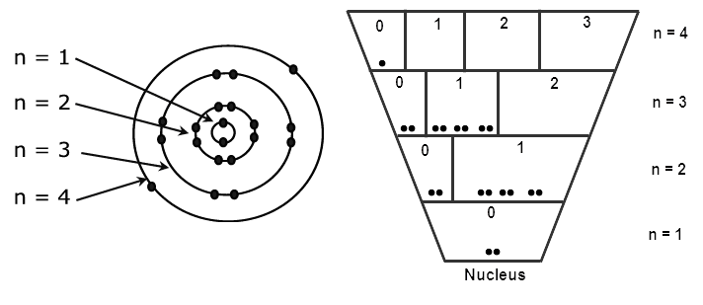
On the n=2 main energy level there are two sub-energy levels. Their values are “0” and “1”.
Figure 3. Refined Bohr model.

Notice that each main energy level is broken up into sub-energy levels. The sub-energy levels (also referred to as subshells) are denoted with the letter l. The size of the sub-energy level in which the electron resides is important, because the energy of the electron is dependent upon the space in which it is likely to exist (larger spaces for example provide the electron more space to move around and contain lower energy electrons). The values of the subshells (l) depend on the value of the principal quantum number, n. Can you spot the pattern?

Skill 9.02 Example 1
- For the n=2, main energy level,
- How many sub-energy levels exist?

- What are their values?

- For the n=3, main energy level,
  - How many sub-energy levels exist?

  - What are their values?

- For the n=5, main energy level,
  - How many sub-energy levels exist?

  - What are their values?

For a given value of n, l has possible integral values of 0 to (n-1).

To avoid confusing main energy levels with sub-energy levels, the value of l is assigned a letter as follows:

l | 0 | 1 | 2 | 3 | 4 | 5
Name of orbital | s | p | d | f | g | h

Each letter also corresponds to a “shape” or region in which the electron is likely to exist:

Figure 4.
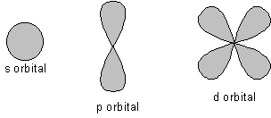

Skill 9.02 Example 2
a. What are the letter designations for the possible subshells on the n=2 main energy level?

- What are the letter designations for the possible subshells on the n=3 main energy level?

Skill 9.03: Define the Magnetic quantum number (m_{l}) and identify the possible values

Skill 9.03 Concepts

The region in which the electron exists (figure 4) can have multiple orientations. To account for the regions, scientists further refined their model. Consider the following,

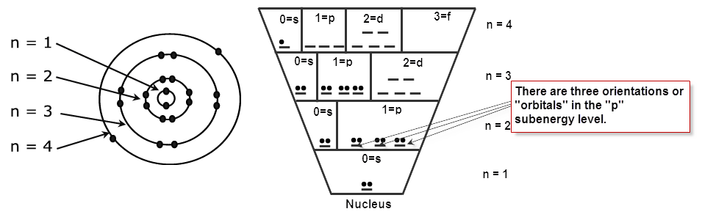
Notice that within each sub-level, there are specific locations in which the electrons can reside. These locations actually correspond to the number of possible orientations the sub-energy level can produce and are referred to as orbitals.

Skill 9.03 Example 1
How many orientations are possible for each sub-energy level?
(a) l=s | (b) l=p | (c) l=d | (d) l=f

The magnetic quantum number (m_{l}) is used to describes the possible orientations. For example,

For l=s or l=0, the number of allowed orientations is “1”. The orbital is assigned the value of 0.
For l=p or l=1, the number of allowed orientations is “3”. The orbital values are -1,0,+1.
For l=d or l=2, the number of allowed orientations is “5”. The orbital values are -2,-1,0,+1,+2

Can you spot the pattern?

Skill 9.03 Example 2
List the possible values of m_{l} for the l=f or l=3 sub-energy level.

The magnetic quantum number (m_{l}) describes the possible orientations. The orientations are also referred to as orbitals. The magnetic quantum number depends on the orbital (l) it describes. For a certain value of l, there are (2l+1) possible m_{l} values that range from -l to +l.

Skill 9.03 Example 3
Complete the n=4 main energy level. For each sub-energy level indicate the number of orientations (aka orbitals) with a “__”. Write the corresponding number below.
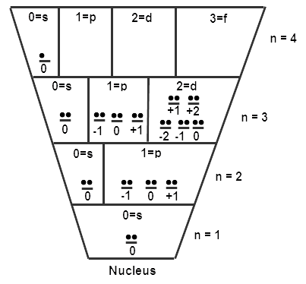

Skill 9.04: State Hund’s rule, state the Pauli exclusion principle, define the Spin quantum number (m_{s}) and identify its possible values and arrangements

Skill 9.04 Concepts

It was known that many elements had magnetic properties. It was also known that a spinning electron induced a magnetic field. In order to account for the observed magnetic properties and the fact that electrons repel one another, Hund proposed that the most stable arrangement of electrons in a subshell is the one with the greatest number of parallel spins. For example, a p subshell (which corresponds to l=p=1) contains 2l+1 = 3 orbitals which range in values from –l to +l , -1, 0, +1. For a three electron system the arrangement of electrons would be as follows:

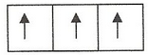

Accounting for the spin quantum number, our atomic model now takes on the following form,
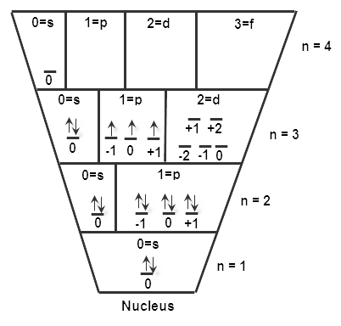
According to Hund’s rule, electrons want to maximize their distance from one another. Notice that we put 1 electron in each orbital before we begin pairing them.

Each electron in this subshell has a spin value of +1/2 because it is pointing up.
Notice in the above model some electrons are spinning up while others are spinning down. For many-electron atoms, we use the Pauli exclusion principle to justify this. This principle states that no two electrons in an atom can have the same four quantum numbers. If two electrons in an atom should have the same n, l, and m_{l} values (that is, two electrons in the same atomic orbital), then they must have different values of m_{s}

Spinning charges generate magnetic fields. Because electrons spin, they act like tiny magnets. The direction of the magnetic field is either up or down. If the electron is pointing up, it has a value of +1/2. If it is pointing down, it has a value of -1/2. The spin is also referred to as the spin quantum number (m_{s}).

Skill 9.01 Example 1
This electron has the following values:

n=3; l=1; m_{l}=+1; m_{s}= +1/2

Or we can also write it using the following short hand notation.

(3, 1, +1, +1/2)

The values in the shorthand method correspond to the following quantum numbers,

(n, l, m_{l}, m_{s})
Consider the atomic model of the atom shown above.
  - How many electrons are in this atom?

  - Assuming the atom is neutral, that is it has equal numbers of protons and electrons. What atom is represented by the diagram?

(c) What are the values of n, l, m_{l}, and m_{s} for each electron on the 3rd main energy level? List their values for each electron using the short hand method shown above.

Skill 9.05: Identify whether an atom diamagnetic or paramagnetic

Skill 9.05 Concepts

As mentioned previously, when an electron spins, it induces a magnetic field. When two electrons are spinning parallel, the magnetic fields are reinforced. Such an arrangement would cause the atom to be attracted to a magnet (paramagnetic). Likewise, when two electrons are spinning opposite, their magnetic fields are cancelled. This arrangement would cause the atom to be repelled by a magnetic (diamagnetic). In order to determine whether an atom is diamagnetic or paramagnetic look for unpaired electrons. If there are no unpaired electrons (e.g., Ar, Ne, Be) then the atom is diamagnetic, otherwise it is paramagnetic.

Skill 9.05 Example 1
(a) Show the filling of electrons for phosphorus in the diagram below.
(b) Predict whether phosphorus is paramagnetic or diamagnetic.
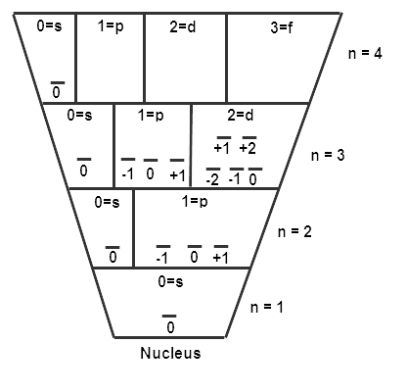

Skill 9.05 Example 2
(a) Draw atomic diagrams for each of the following atoms.
(b) Predict whether each atom is paramagnetic or diamagnetic.
(a) Helium

(b) Nitrogen

(c) Chlorine

(d) Magnesium

Set 9.0 Practice Problems

- Indicate the which of the following sets of quantum number in an atom are unacceptable and explain why:

- (1, 0, ½, ½)
- (3, 0, 0, ½)
- (2, 2, 1, ½)
- (4, 3, -2, ½)
- (3, 2, 1, 1)

- An electron in an atom is in the n=3 quantum level. List the possible values of l and m_{l} that it can have.

- Which of the following species has the most unpaired electrons? S⁺, S, or S⁻. Explain how you arrived at your answer.

- For the following subshells give the values of the quantum numbers (n, l, m_{l}) (a) 4p (b) 3d (c) 3s (d) 5f.

- List all the possible subshells and orbitals associated with the principle quantum number n, if n=5.

- The atomic number of an element is 73. Are the atoms of this element diamagnetic or paramagnetic?

- Indicate the number of unpaired electrons present in each of the following atoms: B, Ne, P, Sc, Mn, Se, Kr, Fe, Cd, I, Pb

- The postulates of the Bohr model of the hydrogen atom can be stated as follows:

- The electron can exist only in discrete states each with a definite energy.
- The electron can exist only in certain circular orbits
- Radiation is emitted by that atom only when an electron makes a transition from a state of higher energy to one of lower energy.

- State whether each of these postulates is currently considered to be correct, according to the wave mechanical description of the hydrogen atom.

- Give the wave mechanical description that has replaced one of the postulates now considered to be incorrect.

- Two important concepts that relate the behavior of electrons in atom systems are the Heisenberg uncertainty principle and the wave-particle duality of matter.5

- State the Heisenberg uncertainty principle as it relates to determining the position and momentum of an object.

- What aspect of the Bohr theory of the atom is considered unsatisfactory as a result of the Heisenberg uncertainty principle?

- Explain why the uncertainty principle or the wave nature of particles is not significant when describing the behavior or macroscopic objects, but it is very significant when describing the behavior of electrons.

Set 10. Photoelectron Spectroscopy and Electron Configurations

Skill 10.01: Calculate the binding energy of an electron
Skill 10.02: Interpret photoelectron spectrums
Skill 10.03: Be able to write electron configurations for an element
Skill 10.04: Apply the Aufbau principle to write electron configurations for an element
Skill 10.05: Be able to write electron configurations given the periodic table
Skill 10.06: Be able to identify whether or not an atom is in its excited given its electron configuration
Skill 10.07: Be able to write abbreviated electron configurations
Skill 10.08: Be able to write electron configurations for ions

Skill 10.01: Calculate the binding energy of an electron

Skill 10.01 Concepts

Each electron in an atom is attracted to the nucleus. The energy necessary to separate an electron from an atom is called the electron’s binding energy. In photoelectron spectroscopy a beam of x-rays is directed at a sample of atoms. The x-rays have much more energy than is necessary to knock these electrons out of the atom, producing a stream of electrons called “photoelectrons”. Because the x-rays have more energy than the binding energy, the photoelectrons exit the atom with a (relatively) large amount of kinetic energy.
The binding energy is the difference between the incoming photon’s energy and the kinetic energy of the photoelectron.

E_{binding energy} = E_{incoming photon} – E_{kinetic energy}

Consider the model of Boron below,
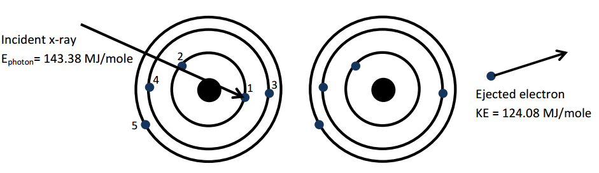
The energy of the incoming photon is 143.38 MJ/mole and the kinetic energy of the ejected electron is 124.08 MJ/mole. There the binding energy is,

143.38 MJ/mole – 124.08 MJ/mole

Skill 10.01 Problem 1
Imagine a sample of neutral boron atoms being struck with x-rays. There are five possible outcomes, depicted below. The boron atoms are depicted using the shell model.
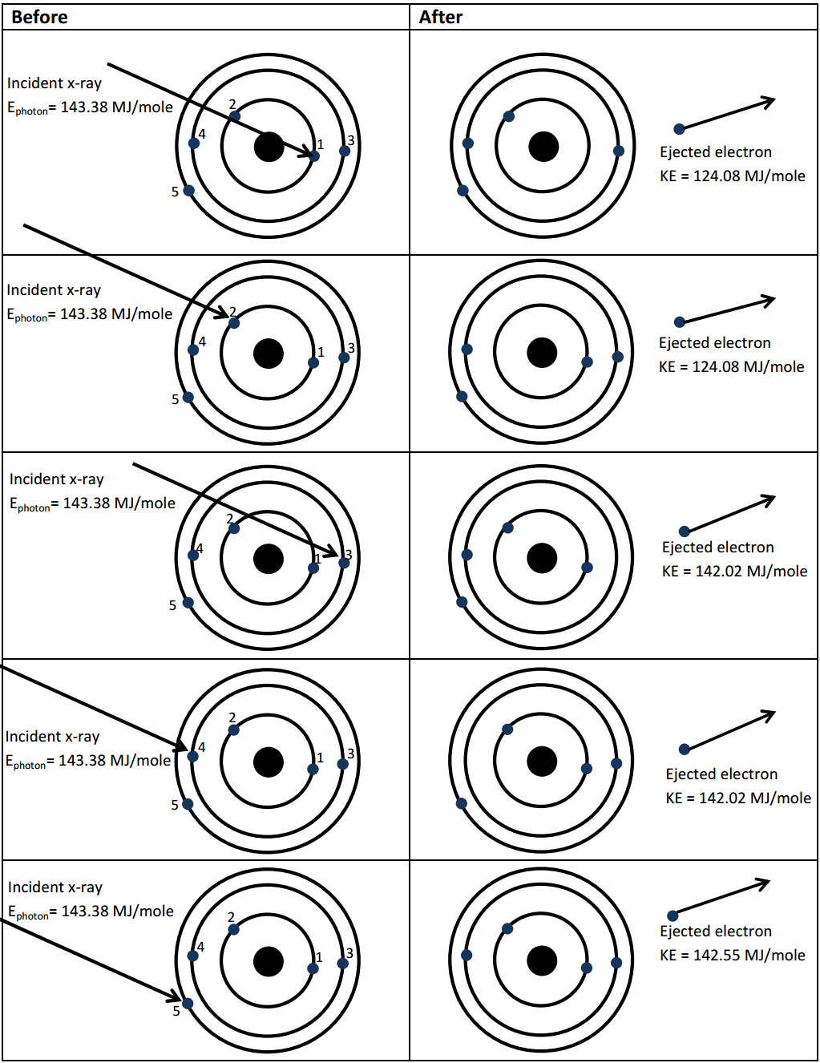
- For all five situations, circle the electron that has been ejected from the atom.

- Complete the table below,
Electron | Kinetic energy | Binding Energy
1
2
3
4
5

- On the table above, note which electrons have the same kinetic energy after being separated from the atom.

- What do the electrons with the same kinetic energy after ejection have in common with each other?

Skill 10.02: Interpret photoelectron spectrums

Skill 10.02 Concepts

Often the data from photoelectron spectroscopy is displayed as a graph of the binding energies. Consider the following model for fluorine,

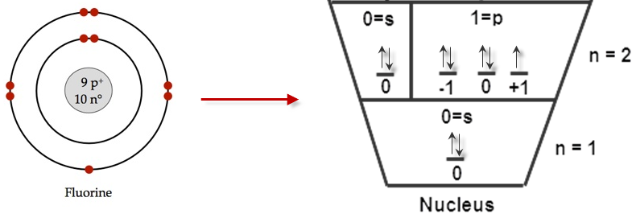

The graph of the binding energies of the electrons is as follows,

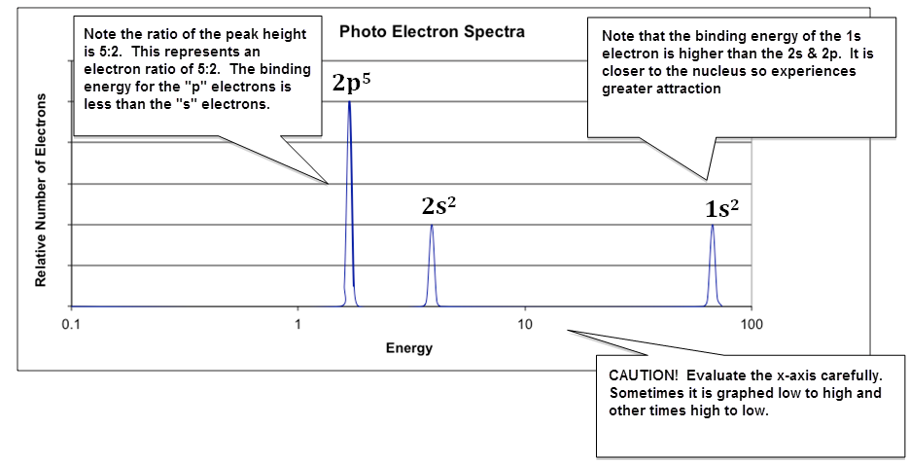

Comparison of spectra beautifully demonstrates how the actual energy of energy levels varies as the nuclear charge, Z, increases. This in turn illustrates why each element has a unique atomic spectrum!

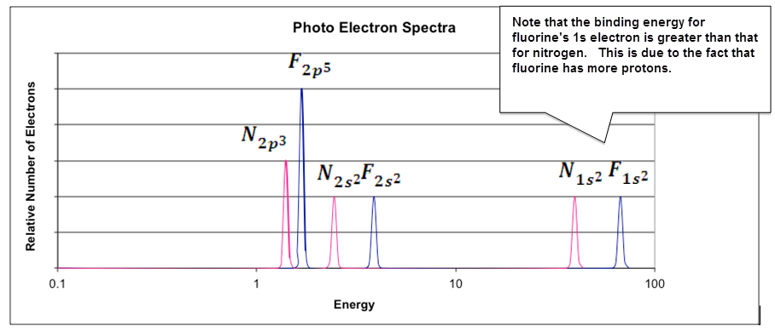

Skill 10.02 Problem 1
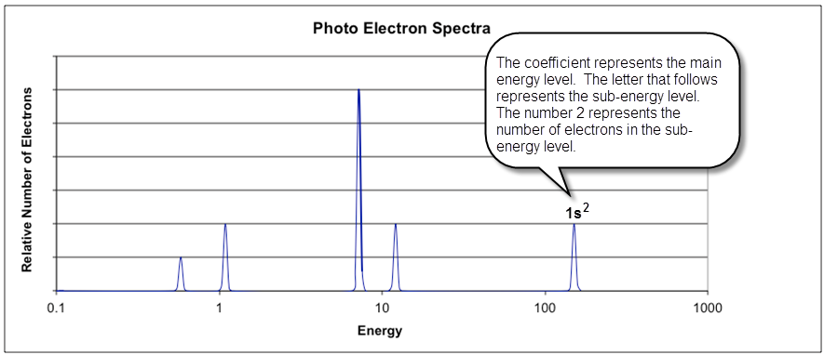
- Identify the element and write its electron configuration.

- The two electrons closest to the nucleus have been labeled on the spectrum. Using this as a guide, label the rest of the peaks.

- Sketch the expected spectrum of phosphorus on the graph, making sure to show the relative changes in positions (not the exact energy) of the peaks and the relative intensity of each peak.

- A student makes the following claim regarding the PES spectra of Mg²⁺ and Ne. Is the statement true or false? Justify your answer. (NOTE, Isoelectronic is just a fancy word that means “having the same number of electrons”)

Skill 10.02 Problem 2
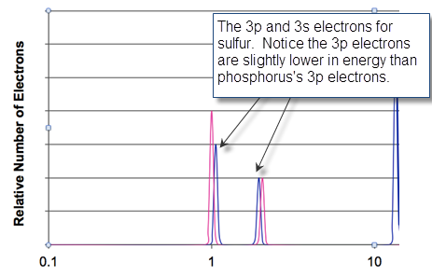
A portion of the PES spectra for phosphorus and sulfur depicting the 3p and 3s electrons is shown above. Although the nuclear charge for sulfur is GREATER than phosphorus, the binding energy for the 3p electrons is unexpectedly LOWER for sulfur. Justify this observation in terms of repulsive and attractive forces.

Now consider the spectrum for scandium (21 electrons). The peak at 433 represents the 1s electrons and the peak at 3.24 represents the 3p electrons. But notice what happens as move left from 3.24. We see a single electron followed by 2 electrons.

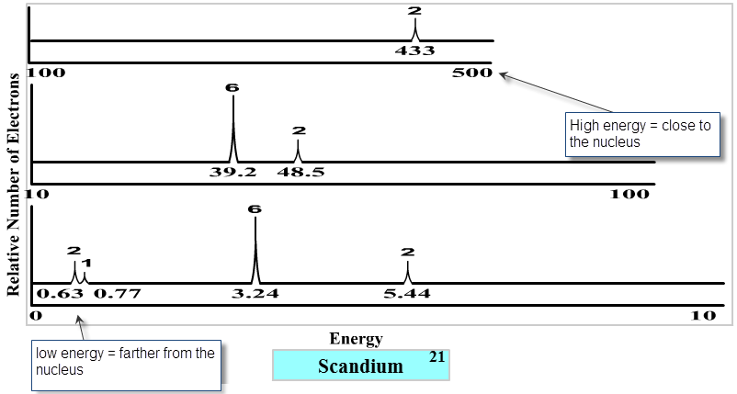

Weird!

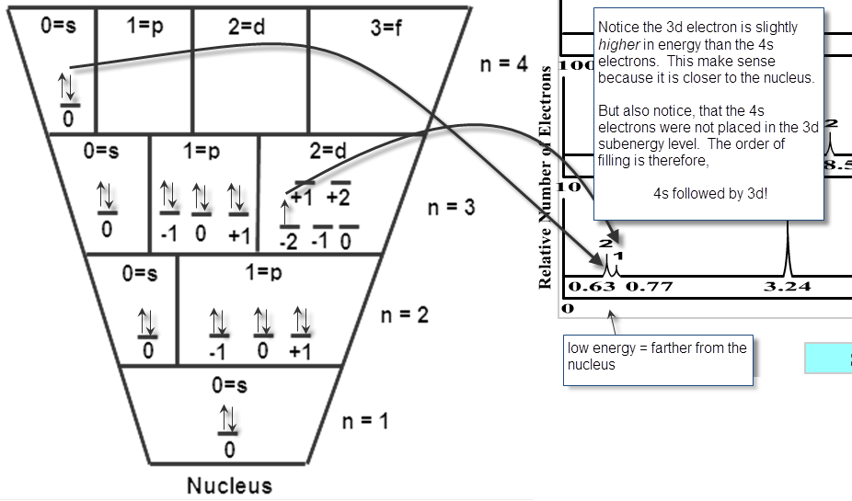

You can think of this behavior as a tug-a-war for stability. While a filled sub-energy level is more stable than an unfilled energy level, electrons also want to be close to the nucleus. As it turns out, atoms will most always fill their 4s sub-energy level before filling their 3d sub-energy level.

Skill 10.02 Problem 3
- Label each peak in the spectrum using the notation illustrated in Skill 10.02 Problem 1.

- If one electron is removed from scandium, which electron requires the least amount of energy to remove? Circle this electron on the spectrum.

- Sketch the expected spectrum of calcium on the graph, making sure to show the relative changes in positions (not the exact energy) of the peaks and the relative intensity of each peak.

Skill 10.03: Be able to write electron configurations for an element

Skill 10.03 Concpets

Photoelectron spectroscopy provides direct evidence for the arrangement of electrons in the atom. Consider the following atomic model and spectrum for fluorine,

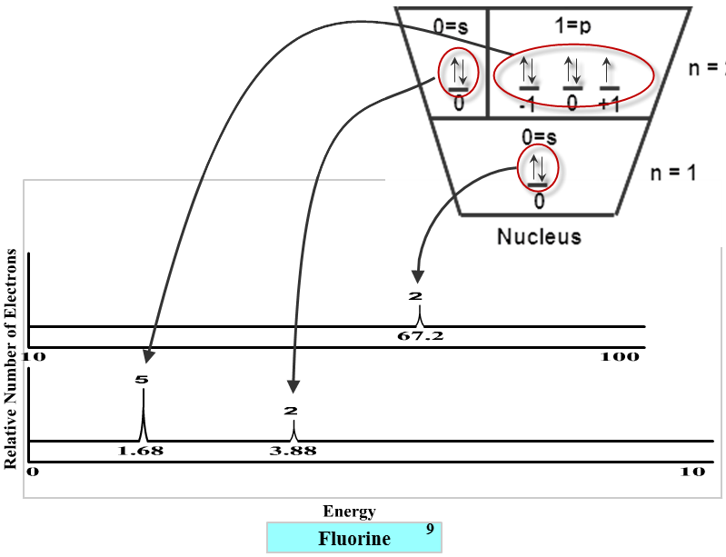

The electron configuration for an atom is used to describe the energies of all the electrons in an atom. And the rules for writing electron configurations are a direct outcome of photoelectron spectroscopy.
Recall the following letter designations for the subshell l and the maximum number of allowed electrons in each subshell

0 => s => 2
1 => p => 6
2 => d => 10
3 => f => 14

When writing electron configurations, the principle quantum number (n) serves as the coefficient in the electron configuration and the sub-energy level to which the electrons belong is written next.

Finally, the number of electrons in the sub-energy level is denoted with a superscript.

For fluorine, the electron configuration would be written as follows, 1s²2s²2p⁵

Skill 10.03 Problem 1
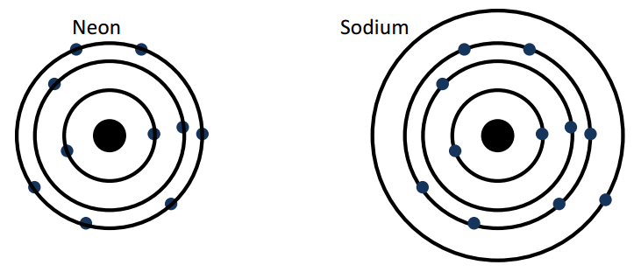
- Draw photoelectric spectra for the atoms shown above. Draw each spectra on top of the other and make sure that the relative energies of each shell are correct.

- Write the corresponding electron configurations for elements shown.

Skill 10.04: Apply the Aufbau principle to write electron configurations for an element

Skill 10.04 Concepts
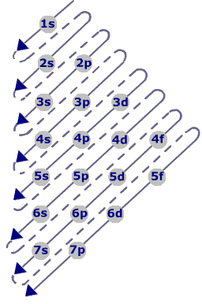
The process for writing electron configurations is based on the Aufbau principle (The German word for building up). This principle dictates that as protons are added one by one to the nucleus to build up the elements, electrons are similarily added to the atomic orbitals. The figure shown right illustrates the order in which electrons are added.

Skill 10.04 Problem 1
Refer to figure 1 to write the ground state electron configurations for the following atoms:
(a) Ne

(b) K

(c) Al

(d) Cr

(e) Cu

The placement of potassium’s outer most electrons in the 4s as opposed to the 3d is strongly supported by experimental evidence. The driving force behind electron arrangements in atoms is stability. Atoms gain stability by filling subshells. The single electron in potassium is placed in the s first because it more closely fills this subshell. There is an irregularity in the pattern for both Cr and Cu however. You wrote 4s¹3d⁵ not 4s²3d⁴ and 4s¹3d¹⁰ not 4s²3d⁹. The reason for this irregularity is that a slightly greater stability is associated with the half filled and filled d orbital.

Skill 10.05: Be able to write electron configurations given the periodic table

Skill 10.05 Concepts

A final note on electron configurations is the relationship between figure 1 and the periodic table. This relationship is illustrated in the figure below.

 |  |  |  | s
s |  |  | p
 |  | d

The periodic table can be used for deducing electron configurations. The periodic table is constructed from four blocks: the s, p, d, and f block.

- The s block is groups 1 and 2. Notice it is only two elements wide and can hold a maximum of two electrons.
- The p block is groups 13-18. Notice it is 6 elements wide and can hold a maximum of 6 electrons.
- The d block is groups 3-12. Notice it is 10 elements wide and can hold a maximum of 10 electrons.
The f block is 14 elements wide and can hold a maximum of 14 electrons

Skill 10.05 Problem 1
Using only the periodic table, write the electron configurations for the following:
- Ne and Na

- Ar and Ca

- Kr and I

Skill 10.06: Be able to identify whether or not an atom is in its excited given its electron configuration

Skill 10.06 Concepts

All the electron configurations encountered so far are called ground state electron configurations. That is all the electrons are in their ground state, or most stable state. As you have seen before, electrons can be excited. When this happens an electron in its ground state can move to a more energetic state. For example, the ground state electron configuration for helium is 1s², however an excited configuration could be 1s¹2s¹. Notice that in the excited configuration, an electron in the 1s energy level was promoted to the 2s energy level.

Skill 10.06 Problem 1
Which of the following represents an electron configuration of an atom, which has been excited? How do you know?

(a) 1s²2s¹2p⁶3s¹
(b) 1s²2s²2p⁶3s²3p⁶4s²3d⁹
(c) 1s²2s²2p⁵3s²3p⁶4s²3d⁹
(d) 1s²2s²2p⁶3s²3p⁶4s²3d¹⁰4p⁵

Skill 10.07: Be able to write abbreviated electron configurations

Skill 10.07 Concepts

Notice in practice 3 that the electron configuration of the noble gas atom (group 18) that directly precedes any element is identical to the early part of the electron configuration for that element. For example, the noble gas that directly precedes chlorine (Cl, atomic number 17) is neon (Ne, atomic number 10). The first 10 electrons in Cl can thus be replaced with the Ne symbol, and the electron configuration of Cl can be written [Ne]3s²3p⁵.

Skill 10.07 Problem 1
Write the abbreviated electron configurations for the following:
Sb

Hg

Mo

Ba

Skill 10.08: Be able to write electron configurations for ions

Skill 10.08 Concepts

Atoms are neutral because their numbers of electrons and protons are equal. When they are not equal they become charged. An atom or molecule with a charge is called an ion.

- Anions are negatively charged ions. The are formed when an atom or molecule gains an electron:

Cl + e- → Cl⁻

In general, nonmetals gain electrons to become anions

- Cations are positively charged ions. They are formed when an atom or molecule loses an electron:

Na → Na⁺ + e-

In general, metals lose electrons to become cations

Atoms tend to gain or lose electrons so they can obtain a noble gas configuration.

For example the electron configuration for He is:

1s²

The electron configuration for Li is:

1s²2s¹

Li loses an electron to become “like” He:

1s²2s¹ → 1s² + e-

OR

Li → Li⁺ + e-

Notice that Li obtains a positive charge because it loses an electron.

Skill 10.08 Problem 1
For each element below:
a. write the electron configuration for the neutral element
b. indicate the most probably ion formed
c. write the electron configuration for the ion formed
Be | Mg
Al | Ga
N | P

Set 11. Periodic Trends

Skill 11.01: Be able to identify alkali metals, alkali earth metals, halogens, noble gases, groups, and periods
Skill 11.02: Be able to compare and contrast metals, nonmetals, and metalloids
Skill 11.03: Describe, in terms of atomic structure, the causes for the following periodic trends: atomic radii, ionization energy, and electronegativity
Skill 11.04: Define ionization energy, describe how it changes going across/down the periodic table
Skill 11.05: Be able to identify the group to which an element belongs given its first five ionizations energies
Skill 11.06: Define atomic radii, describe how it changes going across/down the periodic table
Skill 11.07: Arrange ions in order with respect to atomic radius
Skill 11.08: Define electronegativity, describe how it changes going across/down the periodic table

Skill 11.01: Be able to identify alkali metals, alkali earth metals, halogens, noble gases, groups, and periods

Skill 11.01 Concepts

The vertical columns on the periodic table are groups

Rows are called periods

The elements can be classified as metals, nonmetals, or metalloids

The elements can be further classified as follows:

- Group 1 elements are called the alkali metals
- Group 2 elements are called the alkali earth metals
- Group 17 elements are called the halogens
- Group 18 elements are called the noble gases

1A | 2A | 3B | 4B | 5B | 6B | 7B | 8B | 8B | 8B | 1B | 2B | 3A | 4A | 5A | 6A | 7A | 8A
1 | 2 | 3 | 4 | 5 | 6 | 7 | 8 | 9 | 10 | 11 | 12 | 13 | 14 | 15 | 16 | 17 | 18
1  H  1.0 |  |  |  |  |  |  |  |  |  |  |  |  |  |  |  |  | 2  He  4.0
3  Li  6.9 | 4  Be  9.0 |  |  |  |  |  |  |  |  |  |  | 5  B  10.8 | 6  C  12.0 | 7  N  14.0 | 8  O  16.0 | 9  F  19.0 | 10  Ne  20.1
11  Na  23.0 | 12  Mg  24.3 |  |  |  |  |  |  |  |  |  |  | 13  Al  27.0 | 14  Si  28.1 | 15  P  31.0 | 16  S  32.1 | 17  Cl  35.5 | 18  Ar  40.0
19  K  39.1 | 20  Ca  40.1 | 21  Sc  45.0 | 22  Ti  47.9 | 23  V  50.9 | 24  Cr  52.0 | 25  Mn  54.9 | 26  Fe  55.9 | 27  Co  58.9 | 28  Ni  58.7 | 29  Cu  63.6 | 30  Zn  65.4 | 31  Ga  69.7 | 32  Ge  72.6 | 33  As  74.9 | 34  Se  79.0 | 35  Br  79.9 | 36  Kr  83.8
37  Rb  85.5 | 38  Sr  87.6 | 39  Y  88.9 | 40  Zr  91.2 | 41  Nb  92.9 | 42  Mo  95.9 | 43  Tc  98 | 44  Ru  101 | 45  Rh  103 | 46  Pd  106 | 47  Ag  108 | 48  Cd  112 | 49  In  115 | 50  Sn  119 | 51  Sb  122 | 52  Te  128 | 53  I  127 | 54  Xe  131
55  Cs  133 | 56  Ba  137 | 57  La  139 | 72  Hf  179 | 73  Ta  181 | 74  W  184 | 75  Re  186 | 76  Os  190 | 77  Ir  192 | 78  Pt  195 | 79  Au  197 | 80  Hg  201 | 81  Tl  204 | 82  Pb  207 | 83  Bi  209 | 84  Po  210 | 85  At  210 | 86  Rn  222
87  Fr  223 | 88  Ra  226 | 89  Ac  227 | 104 | 105 | 106 | 107 | 108 | 109 | 110 | 111 | 112 | 113 | 114
 |  |  |  | 58  Ce  140 | 59  Pr  141 | 60  Nd  144 | 61  Pm  147 | 62  Sm  150 | 63  Eu  152 | 64  Gd  157 | 65  Tb  159 | 66  Dy  163 | 67  Ho  165 | 68  Er  167 | 69  Tm  169 | 70  Yb  173 | 71  Lu  175
 |  |  |  | 90  Th  232 | 91  Pa  231 | 92  U  238 | 93  Np  237 | 94  Pu  242 | 95  Am  243 | 96  Cm  247 | 97  Bk  247 | 98  Cf  249 | 99  Es  254 | 100  Fm  253 | 101  Md  256 | 102  No  254 | 103  Lw  257

Nonmetals
Metalloids
Metals

Skill 11.02: Be able to compare and contrast metals, nonmetals, and metalloids

Skill 11.02 Concepts

Metals tend to be shiny solids that are bendable and malleable and conduct heat and electricity well.

Nonmetals tend to be brittle and do not conduct heat or electricity well.
Metalloids (semimetals) can act, depending on circumstances like either metals or nonmetals. They are often referred to as semiconductors.

Skill 11.03: Describe, in terms of atomic structure, the causes for the following periodic trends: atomic radii, ionization energy, and electronegativity

Skill 11.03 Concepts

All periodic trends can be understood in terms of three basic concepts:

- Electrons are attracted to the protons in the nucleus of an atom

- The closer an electron is to the nucleus, the more strongly it is attracted.
- The more protons in a nucleus, the more strongly an electron is attracted.

- Electrons are repelled by other electrons in an atom. So if other electrons are between a valence electron and the nucleus, the valence electron will be less attracted to the nucleus. That’s called shielding.

- Completed shells (and to a lesser extent, completed subshells) are very stable. Atoms prefer to add or subtract valence electrons to complete shells if possible.

Skill 11.04: Define ionization energy, describe how it changes going across/down the periodic table

Skill 11.04 Concepts

Ionization energy is defined as the minimum energy required to remove an electron from an atom.

Electrons are attracted to the nucleus of an atom, so it takes energy to remove an electron. The energy required to remove an electron from an atom is called the first ionization energy.

Once an electron has been removed, the atom becomes positively charged.

Moving from left to right across a period, ionization energy increases

Moving from left to right across a period, protons are added to the nucleus, which increases its positive charge. For this reason, the negatively charged valence electrons are more strongly attracted to the nucleus, which increases the energy required to remove them.

Electrons are also being added, and the shielding effect provided by the filling of the s sub shell causes a slight deviation in the trend in moving from group 2A to 3A. The deviation also arises from the fact that removing an electron from a full sub shell tends to take more energy than removing an electron from an unfilled sub shell.

Moving down a group, ionization energy decreases

Moving down a group, shells of electrons are added to the nucleus. Each inner shell shields the more distant shells from the nucleus, reducing the pull of the nucleus on the valence electrons and making them easier to remove.

Protons are also being added, but the shielding effect of the negatively charged electron shells cancels out the added positive charge.

Skill 11.04 Example 1
a. Arrange the following in order from low to high with respect to ionization energy

(i) Na, Li, K, Cs, Rb
(ii) Cl, Na, Al, S, Mg

b. Justify your reasoning in terms of atomic principles

Skill 11.05: Be able to identify the group to which an element belongs given its first five ionizations energies

Skill 11.05 Concepts

The energy required to remove the first electron from an atom is also called the first ionization energy. Likewise the energy required to remove the second electron from an atom is called the second ionization energy; the energy required to remove the third electron is called the third ionization energy, etc.

The second ionization energy is always greater than the first ionization energy, the third ionization energy is always greater than the second, and so on. This is because, once an electron has been removed from an atom, electron-electron repulsion decreases and the remaining valence electrons move closer to the nucleus, making them more difficult to remove.

For example, consider the first five ionization energies for an unknown element:

510 kJ/mol , 840 kJ/mol, 9300 kJ/mol, 16,000 kJ/mol, 18,000 kJ/mol

Notice the gradual increase from the first ionization to the second, then the large jump between the second and the third (~10x). This trend occurs because as electrons are removed, ionization energy increases gradually until a shell is empty, then it makes a BIG jump. The unknown element must therefore belong to group II, because the first two ionization energies are comparable.

Skill 11.05 Example 1
a) The first three ionization energies of some element are as follows:

I₁ = 520 kJ/mol, I₂ = 7300 kJ/mol, I₃ = 11815 kJ/mol

Which of the following could represent the element: Na, Cl, Ca, Al Explain.

b) The first five ionization energies of some element are as follows:

I₁ = 1086 kJ/mol, I₂ = 2350 kJ/mol, I₃ = 4620 kJ/mol, I₄ = 6220 kJ/mol, I₅ = 38,000kJ/mol

To which group does this element belong?

Skill 11.05 Example 2
Consider the following electronic configurations for 3 different neutral atoms.

1s²2s²2p⁶
1s²2s²2p⁶3s¹
1s²2s²2p⁶3s²

(a) Which atom has the largest first ionization energy? Explain.

(b) Which atom has the smallest first ionization energy? Explain.

(c) Which atom has the largest second ionization energy? Explain.

Skill 11.06: Define atomic radii, describe how it changes going across/down the periodic table

Skill 11.06 Concepts

The atomic radius is the approximate distance from the nucleus of an atom to its valence electrons.

Moving from left to right across a period (Li to Ne, for instance), atomic radius decreases

Moving from left to right across a period, protons are added to the nucleus, so the valence electrons are more strongly attracted to the nucleus, decreasing the atomic radius.

Electrons are also being added, but they are all in the same shell at about the same distance from the nucleus, so there is not much of a shielding effect.

Moving down a group (Li to Cs, for instance), atomic radius increases

Moving down a group, shells of electrons are added to the nucleus. Each shell shields the more distant shells from the nucleus and the valence electrons get farther and farther away from the nucleus.

Protons are also being added, but shielding effects of the negatively charged electron shells cancels out the added positive charge.

Skill 11.06 Example 1
Arrange the following from low to high with respect to atomic radius. Justify your reasoning.
Mg, Na, Ar, Al | Rb, K, Li, Cs

Skill 11.07: Arrange ions in order with respect to atomic radius

Skill 11.07 Concepts

Cations (positively charged ions) are smaller than atoms

When an electron is removed from an atom, forming a cation, the electron-electron repulsions are reduced an all of the valence electrons move closer to the nucleus.

Anions (negatively charged ions) are larger than atoms

When an electron is added to an atom, forming an anion, electron-electron repulsions increase, causing the valence electrons to move farther apart and increasing the radius.

To compare the atomic radii of ions, the electron/proton ratio must be considered. Consider the following example:

Arrange the following from high to low with respect to atomic radius:

Ca²⁺, K⁺, S²⁻, Ar

For each element, count the electrons and protons:

 | Ca²⁺ | K⁺ | S²⁻ | Ar
Electrons | 20-2=18 | 19-1=18 | 16+2=18 | 18
protons | 20 | 19 | 16 | 18

Notice all the elements have the same number of electrons, that is they are isoelectronic, therefore what causes one element to be larger or smaller is going to be determined by the number of protons. The element with the fewest protons will be the largest because its electrons experience the weakest attractive forces. The expected order from smallest to largest is therefore:

Ca²⁺, K⁺, Ar, S²⁻

Skill 10.07 Example 1
a) Which of the following has the smallest atomic radius? Explain.

Ne, O²⁻, Na⁺, Mg²⁺

b) Which of the following has the smallest atomic radius? Explain.

Al³⁺, Ne, O²⁻, N³⁻

Skill 11.08: Define electronegativity, describe how it changes going across/down the periodic table

Skill 11.08 Concepts

Electronegativity refers to how strongly the nucleus of atom attracts the electrons of other atoms in a bond. Electronegativities of elements are estimated based on ionization energies and electron affinities.

Moving from left to right across a period, electronegativity increases

Protons are added as you move left to right, and therefore the attraction for electrons is greater.

Moving down a group, electronegativity decreases

Due to shielding, the protons in the nucleus do not have much of an affinity for electrons.

Skill 11.08 Example 1
Arrange the following from low to high with respect to electronegativity.

a) F, Mg, Na, Cl

b) I, Cl, F, Br

Skill 11.09: Define electron affinity, describe how it changes going across/down the periodic table

Skill 11.09 Concepts

The attraction of an atom for electrons is the electron affinity. More specifically, it is the energy given off or added when an electron is added to an atom. If the addition of an electron makes the atom more stable, then energy is given off. If the addition of an electron makes the atom less stable, then energy is required.

Moving left to right across a period, the energy given off when an electron is added increases.

Protons are added as you move left to right, and therefore the affinity for electrons is greater.

Electron affinities don’t change much moving down a group.

Due to shielding, the protons in the nucleus do not have much of an affinity for electrons.

Summary

The diagram below summarizes the trends covered in this topic

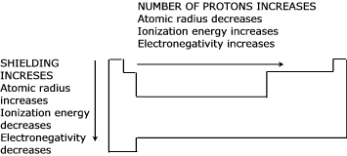
Set 11.0 Practice Problems

- The first ionization energy of an unknown element is 738.1 kJ/mol, the second is 1450 kJ/mol, and the third is 7740 kJ/mol.

- Based on this information what group is the element most likely from. Explain.

- Calculate the amount of energy required to remove the first two electrons from one mole of this element.

- Calculate the energy required to remove the first two electrons from an atom of this element.

- What is the wavelength of this light?

- Use the details of modern atomic theory to explain each of the following experimental observations.

- Within a family such as the alkali metals, the ionic radius increases as the atomic number increases.

- The radius of the chlorine atom is smaller than the radius chloride ion, Cl-.

- The first ionization energy of aluminum is lower than the first ionization energy of magnesium.

- For magnesium, the difference between the second and third ionization energies is much larger than the difference between the first and second ionization energies.

- Briefly (in one to two sentences) explain each of the following in terms of atomic structure:

- In general, why is there an increase in the first ionization energy from Li to Ne?

- Why is the first ionization energy of B lower than that of Be?

- Why is the first ionization energy of O lower than that of N?

- Predict how the first ionization energy of Na compares to those of Li and of Ne. Explain

- Account for each of the following in terms of principles of atomic structure, including the number, properties, and arrangements of subatomic particles.

- The second ionization energy of sodium is about three times greater than the second ionization energy of magnesium.

- The difference between the atomic radii of Na and K is relatively large compared to the difference between the atomic radii of Rb and Cs.

- A sample of nickel chloride is attracted into a magnetic field, whereas a sample of solid zinc chloride is not.

- Use the principles of atomic structure and/or chemical bonding to answer each of the following.

- The radius of the Ca atom is 0.197 nanometer; the radius of the Ca²⁺ ion is 0.099 nanometer. Account for this difference.

- Explain the difference between Ca and K in regard to

(i) Their first ionization energies

(ii) Their second ionization energies

- The first ionization energy of Mg is 738 kilojoules per mole and that of Al is 578 kilojoules per mole. Account for this difference.

- Explain each of the following observations using principles of atomic structure and/or bonding.

- Potassium has a lower first-ionization energy than lithium

- The ionic radius of N³⁻ is larger than that of O²⁻

- A calcium atom is larger than a zinc atom

- Boron has a lower first ionization energy than beryllium

- Answer the following questions about the element selenium, Se (atomic number 34).

- Samples of natural selenium contain six stable isotopes. In terms of atomic structure, explain what these isotopes have in common, and how they differ.

- Write the complete electron configuration (e.g., 1s²2s²…etc) for a selenium atom in the ground state. Indicate the number of unpaired electrons in the ground-state atom, and explain your reasoning.

- In terms of atomic structure, explain why the first ionization energy of selenium is

(i) less than that of bromine (atomic number 35), and
(ii) greater than that of tellurium (atomic number 52).

- Use the principles of atomic structure and/or chemical bonding to explain each of the following. In each part your answer must include reference to both substances.

- The atomic radius of Li is larger than that of Be

- The second ionization energy of K is greater than the second ionization of Ca.

From The College Board Advanced Placement Chemistry Exam, 1999.
Adapted from The College Board Advanced Placement Chemistry Exam, 1978.
From The College Board Advanced Placement Chemistry Exam, 1987.
Adapted from The College Board Advanced Placement Chemistry Exam, 1990.
Adapted from The College Board Advanced Placement Chemistry Exam, 1993.
Adapted from The College Board Advanced Placement Chemistry Exam, 1994.
From The College Board Advanced Placement Chemistry Exam, 1997.
Adapted from The College Board Advanced Placement Chemistry Exam, 2000.
Adapted from The College Board Advanced Placement Chemistry Exam, 2002.

